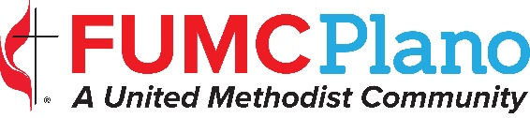

Communications Request
(Please save a copy to your files before completing the form. Incomplete forms will be returned.)
Today’s date: Sponsoring Ministry:

EVENT DETAILS
Event Name: |  |  | Date of Event:
Time Event Begins: | Time Event Ends: |  | Number Expected:
On-Site Location: |  |  | Off-Site Location:
Online Registration? Yes No |  | What is the fee? none | Has the fee been approved? Yes No
Is fee paid to the church? Yes No |  | If no, to whom?
Is child care available? Yes No

publicity checklist Publicity starts immediately? x Yes No if no, when?________________
DESIGN/PRINT | ONLINE PUBLICITY | WORSHIP
Graphic Yes No | FirstNews (Weekly E-mail) Yes No | FirstNotes (Bulletin) Yes No
Brochure/Flyer Yes No | Website Yes No | Worship/Monitor Slides Yes No
Banner /Poster Yes No | Social Media Yes No | Ministry Moment Yes No
External Media Yes No |  | Pulpit Announcement Yes No
The Communications team reserves the right to determine which publicity tools are used.
See Timelines document for lead time needed for the various publicity tools.

Contact Details
Person Making Request:
Email Address: |  |  |  | Phone Number:

* * * required * * *
This information is required: Describe event or activity OR attach information. Think who, what, when,
where and why. Include contact name and e-mail (limit of 2) if it’s someone other than person making request.

Return this form to Nancy Bryan (nbryan@firstmethodistplano.org)
Be sure to complete the CALENDAR REQUEST and return to Victoria Shaw (vshaw@firstmethodistplano.org)

Approved Details (To be completed by staff) approved Yes No

Staff Signature Date

